Station #1

Step 1.

Reread paragraphs 4-6 of “Story of an Hour.”

Step 2.

Underline the imagery in those paragraphs.

Step 3.

In box #1 on your piece of paper, describe the imagery in your own words in 2-3 sentences.

(Note: Consider what Mrs. Mallard might be seeing, hearing, feeling, or smelling.)

Step 4.

Also in box #1, answer these questions:

What might this imagery symbolize? Why is this imagery important to the story?

Station #2

Step 1.

Reread paragraphs 18 and 19 of “Story of an Hour.”

Step 2.

Underline the imagery in those paragraphs.

Step 3.

In box #2 on your piece of paper, describe the imagery in your own words in 2-3 sentences.

(Note: Consider what Mrs. Mallard might be seeing, hearing, feeling, or smelling.)

Step 4.

Also in box #2, answer these questions:

How does the imagery shift from paragraph 18 to paragraph 19? How is this significant?

Station #3

Step 1.

Briefly review the notes you have made in the margins of “Story of an Hour.”

Step 2.

Locate the thesis statement of the story and highlight it. Write the thesis statement in box #3 on your paper.

(Note: A thesis statement is a sentence in the story that identifies the main idea or purpose.)

Step 3.

Also in box #3 on your piece of paper, write one of the major themes of the story. Provide two details from the story that support your answer.

(Note: The theme should not be one word. It should be in a sentence.)

Station #4

Step 1.

Scan the following QR code with your phone.

You may also find the website by using this link on your phone or on the computer:

http://bit.ly/19oiAL9

Step 2.

On the website, read the sections titled “History” and “Domesticity in Literature.”

Step 3.

In box #4 on your piece of paper, write 3 things you learned from the article.

Step 4.

Also in box #4, answer these questions:

What was a woman’s life like in the late 19th century? How does Chopin represent this in “Story of an Hour”?
Station #5

Step 1.

Review what a plot diagram looks like below:

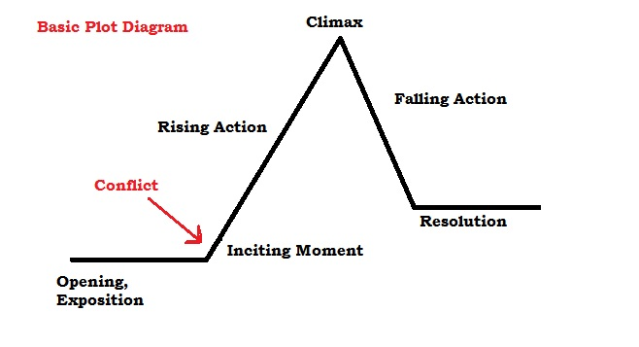

Step 2.

In box #5, draw your own plot diagram.

Step 3.

Also in box #5, complete the plot diagram for “Story of an Hour.” Make sure you include exposition, conflict, rising action, climax, falling action, and resolution.

Station #6

Step 1.

Locate and highlight the following words in “Story of an Hour”:

Veiled (paragraph 2)
Subtle (paragraph 9)
Vacant (paragraph 10)
Keen (paragraph 10)

Step 2.

Use your phone or a dictionary to find the definitions of the four words. Write the words and their definitions in box #6.

Step 3.

Also in box #6, make your own sentences using the vocabulary words.

(Hint: All of these words are adjectives.)

